# Exercises: Data Types and Methods

Problems for exercises and homework for the [“Programming Fundamentals” course @ SoftUni](https://softuni.bg/courses/programming-fundamentals).

You can check your solutions here: <https://judge.softuni.bg/Contests/171/Data-Types-and-Methods-Lab>.

## Centuries to Minutes

### Write program to enter an integer number of centuries and convert it to years, days, hours and minutes

### Examples

|  |  |
| --- | --- |
| **Input** | **Output** |
| 1 | 1 centuries = 100 years = 36524 days = 876576 hours = 52594560 minutes |
| 5 | 5 centuries = 500 years = 182621 days = 4382904 hours = 262974240 minutes |

### Hints

* Use appropriate data type to fit the result after each data conversion.
* Assume that a year has 365.2422 days at average ([the Tropical year](https://en.wikipedia.org/wiki/Tropical_year)).

### Solution

You might help yourself with the code below:

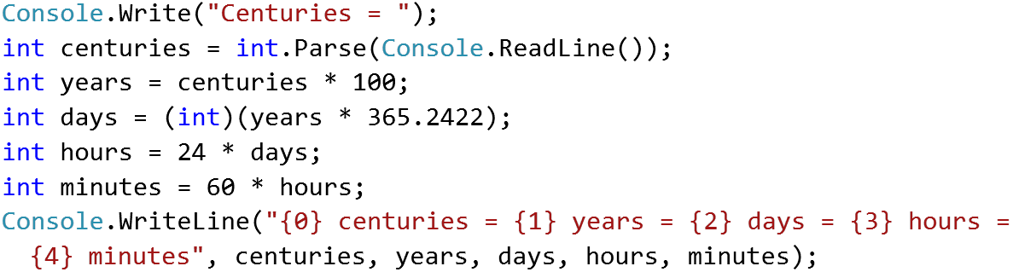

## Circle Area (12 Digits Precision)

### Write program to enter a radius r (real number) and print the area of the circle with exactly 12 digits after the decimal point. Use data type of enough precision to hold the results.

### Examples

|  |  |  |  |  |
| --- | --- | --- | --- | --- |
| **Input** | **Output** |  | **Input** | **Output** |
| 2.5 | 19.634954084936 |  | 1.2 | 4.523893421169 |

### Hints

* You might use the data type double. It has precision of 15-16 digits.
* To print the output with exactly 12 digits after the decimal point, you might use the following code:

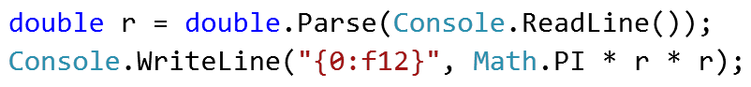

## Exact Sum of Real Numbers

Write program to enter n numbers and calculate and print their **exact sum** (without rounding).

### Examples

|  |  |  |  |  |
| --- | --- | --- | --- | --- |
| **Input** | **Output** |  | **Input** | **Output** |
| 3  1000000000000000000  5  10 | 1000000000000000015 |  | 2  0.00000000003  333333333333.3 | 333333333333.30000000003 |

### Hints

* If you use types like float or double, the result will lose some of its precision. Also it might be printed in scientific notation.
* You might use the decimal data type which holds real numbers with high precision with less loss.
* Note that decimal numbers sometimes hold the unneeded zeroes after the decimal point, so 0m is different than 0.0m and 0.00000m.

## Elevator

Calculate how many courses will be needed to **elevate n persons** by using an elevator of **capacity of p persons**. The input holds two lines: the **number of people n** and the **capacity p** of the elevator.

### Examples

|  |  |  |
| --- | --- | --- |
| **Input** | **Output** | **Comments** |
| 17  3 | 6 | 5 courses * 3 people + 1 course * 2 persons |
| 4  5 | 1 | All the persons fit inside in the elevator.  Only one course is needed. |
| 10  5 | 2 | 2 courses * 5 people |

## Hints

* You should **divide** n **by** p. This gives you the number of full courses (e.g. 17 / 3 = 5).
* If n does not divide p without a remainder, you will need one additional partially full course (e.g. 17 % 3 = 2).
* Another approach is to round up n / p to the nearest integer (ceiling), e.g. 17/3 = 5.67 🡪 rounds up to 6.
* Sample code for the round-up calculation:



## Special Numbers

A **number** is **special** when its **sum of digits is 5, 7 or 11**.

Write a program to read an integer n and for all numbers in the range **1…n** to print the number and if it is special or not (True / False).

### Examples

|  |  |
| --- | --- |
| **Input** | **Output** |
| 15 | 1 -> False  2 -> False  3 -> False  4 -> False  5 -> True  6 -> False  7 -> True  8 -> False  9 -> False  10 -> False  11 -> False  12 -> False  13 -> False  14 -> True  15 -> False |

### Hints

To calculate the sum of digits of given number num, you might repeat the following: sum the last digit (num % 10) and remove it (sum = sum / 10) until num reaches 0.

## Triples of Latin Letters

Write a program to read an integer **n** and print all **triples** of the first **n small Latin letters**, ordered alphabetically:

### Examples

|  |  |
| --- | --- |
| **Input** | **Output** |
| 3 | aaa  aab  aac  aba  abb  abc  aca  acb  acc  baa  bab  bac  bba  bbb  bbc  bca  bcb  bcc  caa  cab  cac  cba  cbb  cbc  cca  ccb  ccc |

### Hints

Perform 3 nested loops from 0 to n-1. For each number num print its corresponding Latin letter as follows:



## Greeting

Write a program that enters **first name**, **last name** and **age** and prints "***Hello, <first name> <last name>. You are <age> years old.***". Use interpolated strings.

### Examples

|  |  |
| --- | --- |
| **Input** | **Output** |
| Svetlin  Nakov  25 | Hello, Svetlin Nakov. You are 25 years old. |

### Hints

You might use the following code:



## Day of Week

Print the day name (in English) by day number in range [1...7] or print “**Error**” for invalid day number.

### Examples

|  |  |
| --- | --- |
| **Input** | **Output** |
| 1 | Monday |
| 2 | Tuesday |
| 3 | Wednesday |
| 4 | Thursday |
| 5 | Friday |
| 6 | Saturday |
| 7 | Sunday |
| -1 | Error |

### Hints

Use the switch-case statement.

## Animal Type

### Write a program to print animal type by its name:

### dog -> mammal

### crocodile, tortoise, snake -> reptile

### others -> unknown

### Examples

|  |  |
| --- | --- |
| **Input** | **Output** |
| dog | mammal |
| snake | reptile |
| cat | unknown |

### Hints

Use the switch-case statement.

## Filled Square

Write a program to draw at the console a **filled square** of size **n** like in the examples below.

1. First write a **method** to print the **header** / **footer** **rows**:

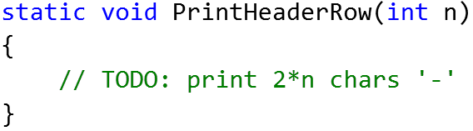

1. Then write another **method** to print the **middle rows**:

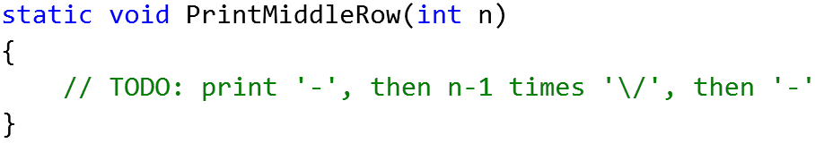

1. Print the entire filled square by **invoking the above two methods**.

### Examples

|  |  |
| --- | --- |
| **Input** | **Output** |
| 3 | **------**  **-\/\/-**  **------** |
| 4 | **--------**  **-\/\/\/-**  **-\/\/\/-**  **--------** |